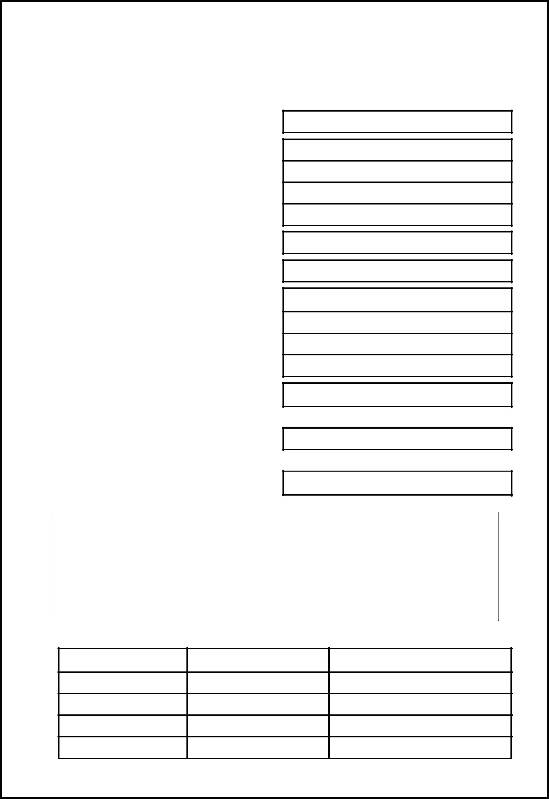
(Form – 403 is deleted by Notification No. STR-1506/CR-38/Taxation-1 Dt.08.09.2006)

FORM 403

(See rule 40(1)(c))

Yearly Statement of the tax deducted at source, to be sent to prescribed Authority under sub-section (10) of section 31 of the Maharashtra Value Added Tax Act, 2002

1 Statement of tax deducted for the year

- Name and address of the Employer

3 Tax Deduction Account No

4 R. C. No. under MVAT Act, 2002 if any

- Name and address of the works contractor from whom deduction of tax has been made

- R.C. No. under MVAT Act, 2002 of the works contractor, if any

7 Total amount credited or amount paid during the year

- Amount of tax deducted at source and date(s)of such deduction(s) has been made

Amount of tax deducted | Date of deduction of tax

- Details of remittance of tax deducted

Amount | Chalan No. and Date | Name and address of Government
 |  | Treasury/Bank
(1) | (2) | (3)

1


Certified that the amount of Rs. _____________ (in figures) Rupees________________________
_____________________(in words) has been deducted from the total amount credited / paid to the dealer in respect of part / full execution of works contract and the same has been deposited in the above stated Government Treasury /Bank.

 |  |  |  | Signature of the person
Place |  |  |  | deducting tax
Dated |  |  |  | Status

2

